

**PROJECT**

**PANTAU COVID-19**

Name :1. Hanas Bayu Pratama (1820010087)

2. Muhammad Dani Setiawan (1820010114)

Faculty : Mr. Fachran Nazarullah, S.Kom

Semester : 4

Quarter : 7

Class : 4SC5

**Contiuning Education Program on Computer for Computing and**

**Information Technology**

**Faculty of Engineering, University of Indonesia**

**Developed by**

1. **Hanas Bayu Pratama**
2. **Muhammad Dani Setiawan**



**PROJECT ON**

*Pantau covid*

**Pantau Covid-19**

Batch Code : 4SC5

Start Date : March 24, 2020   
End Date : April 1, 2020

Name of Faculty : Mr. Fachran Nazarullah, S.Kom

Names of Developer :

1. Hanas Bayu Pratama
2. Muhammad Dani Setiawan

Date of Submission: April 1,2020

**CERTIFICATE**

This is to certify that this report titled “Pantau Covid-19” embodies the original work done by Hanas Bayu Pratama and Muhammad Dani Setiawan. Project in partial fulfillment of their course requirement at NIIT.

Coordinator:

Mr. Fachran Nazarullah, S.Kom



**ACKNOWLEDGEMENT**

Developers have benefited a lot from the feedback and suggestions given to us by Mr. Fachran Nazarullah as a faculty. Developer make this project to fulfill our assignment.

First of all, praises and thanks to Allah SWT that gives the developers all the grace to finish writing the paper entitled “Pantau Covid-19”.

We are working on this paper from the results of our group collaboration and assistance from several parties. Therefore we thank you for the help of the parties involved. But we realize that this paper is still not perfect in arrangement and the content. Then the writer hopes the criticism from the readers can help the writer in perfecting the next paper. Last but not the least that hopefully, this paper can help the readers to gain more knowledge about Flutter.

If the writer made a mistake in writing the Pantau Covid-19, writer ask for forgive to all readers and audiences.

**SYSTEM ANALYSIS**

**System Summary**:

Corona pandemic is the biggest threat in the world at this time so that the country uses policies to reduce the spread of the corona virus. Corona virus currently affects more than 800,000 people worldwide and public knowledge of the number of people infected is very important. in addition, knowledge of how to prevent the corona virus is needed by the general public.

Particularly Indonesian citizens, the spread of the Indonesian corona virus is increasing every day so that public knowledge is needed to prevent the corona virus, especially the public's knowledge about the number of cases of people infected with the corona virus very much. needed to keep the public alert.

Through the application that we made, namely "Pantau Covid-19" the public can find out about the prevention of the corona virus so that the community is not infected with the corona virus so as to reduce the cases of people infected with the corona virus in Indonesia. in addition, this application can display data on the number of patients who are infected, cured, and died so that the public can be alert.

This application can also help someone who shows symptoms of the corona virus but is uncertain and someone who has contracted the corona virus. people who have symptoms of corona virus but may not be able to use the Ask Doctors menu for consultation and people who have contracted the corona virus can immediately use the Referral Hospital menu to be treated immediately

**DESIGN INTERFACE**

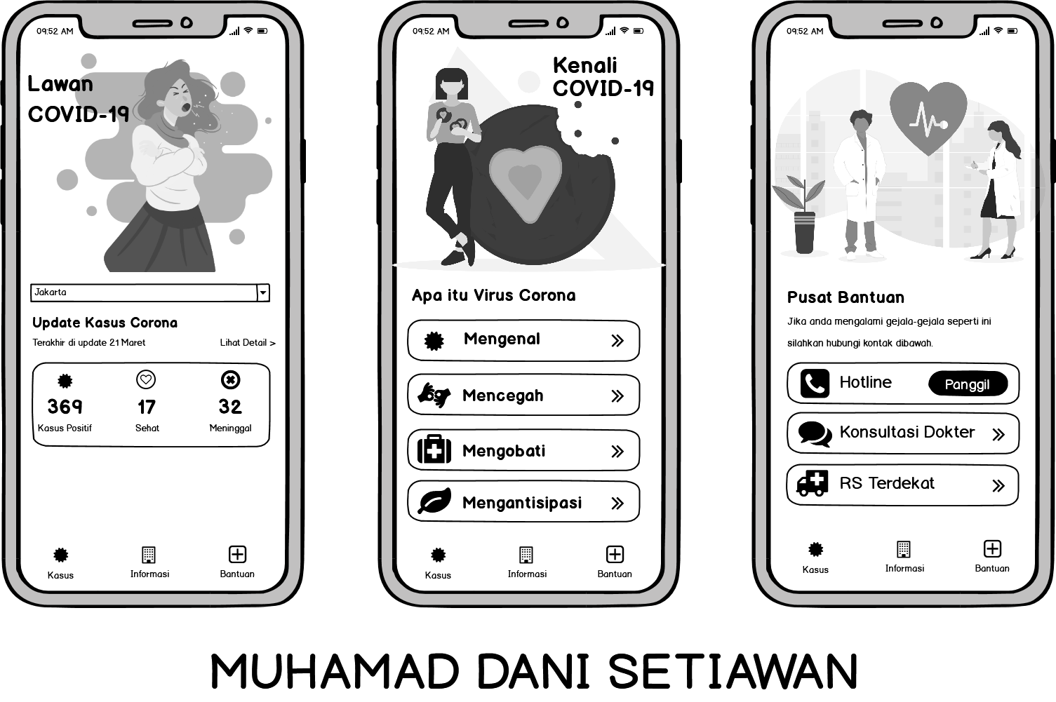

\

sssssssssss

**USER INTERFACE**

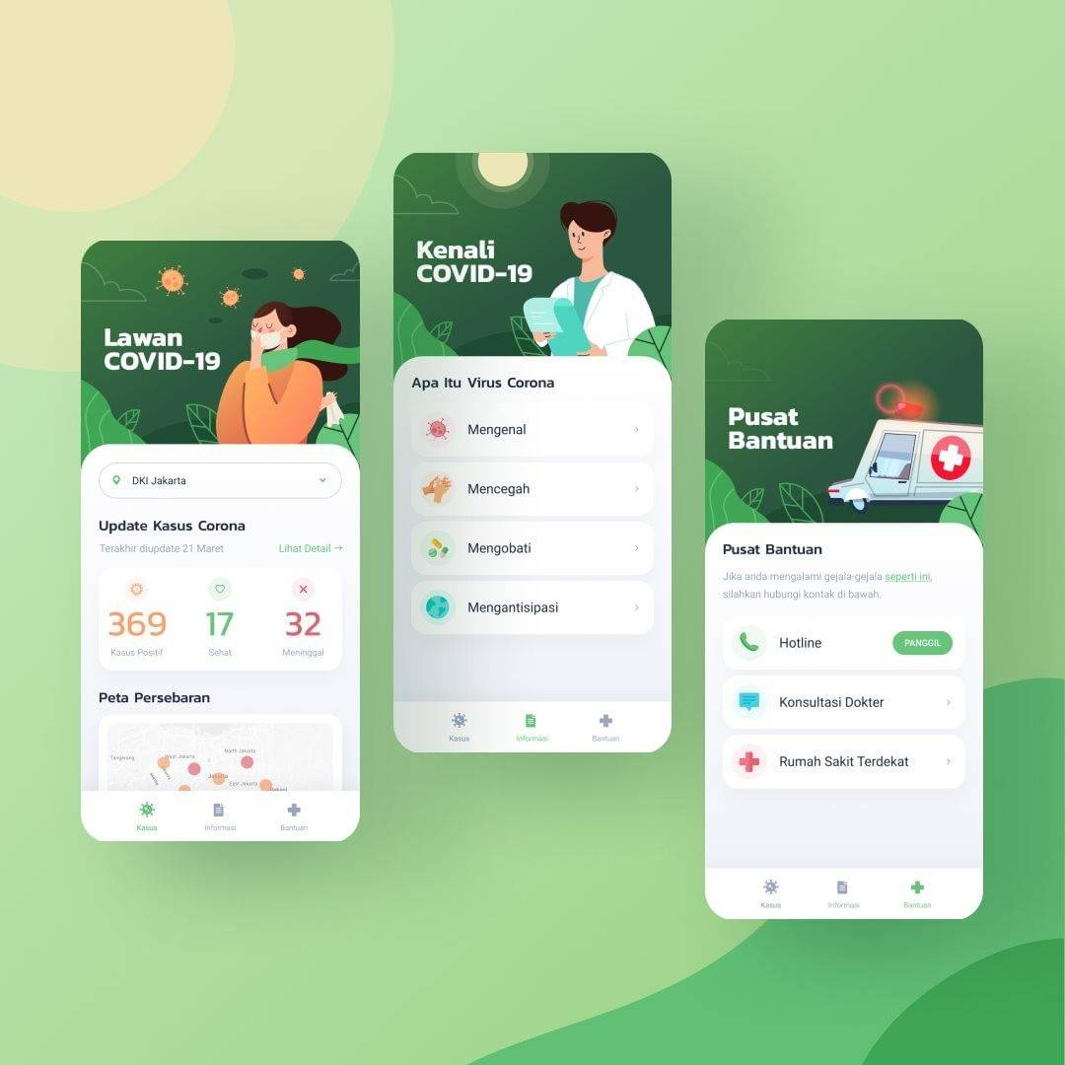

**PROJECT FILE DETAILS**

|  |  |  |
| --- | --- | --- |
| **S.No** | **File Name** | **Remarks** |
| 1 | main.dart | Display Home Page |
| 2 | provider_corona.dart | Link API |
| 3 | pages_kasus.dart | Display a lot of asymptomatic patients |
| 4 | pages_informasi.dart | Display Information About Covid-19 |
| 5 | pages_bantuan.dart | Display Information About Emergency |
| 6 | model_indonesia.dart | Model |
| 7 | model_dunia.dart | Model |
| 8 | model_detail_indonesia.dart | Model |
| 9 | model_detail_dunia.dart | Model |

\

sssssssssss